LAB # 07
Introduction to HTML (Basic Concept, Code and Syntax)


Fall 2022

CSE101L Computer Fundamentals Lab

Submitted by: Haris Khan
Registration No. : 60032
Class Section: A

“On my honor, as student of University of Engineering and Technology, I have neither given nor received unauthorized assistance on this academic work.”

Student Signature: ______________

Submitted to:
Engr. Abdullah Hamid
December 22, 2022
Department of Computer Systems Engineering
University of Engineering and Technology, Peshawar

Step#01:
In the first step, I coded in HTML for my topic present below in the screen shot.
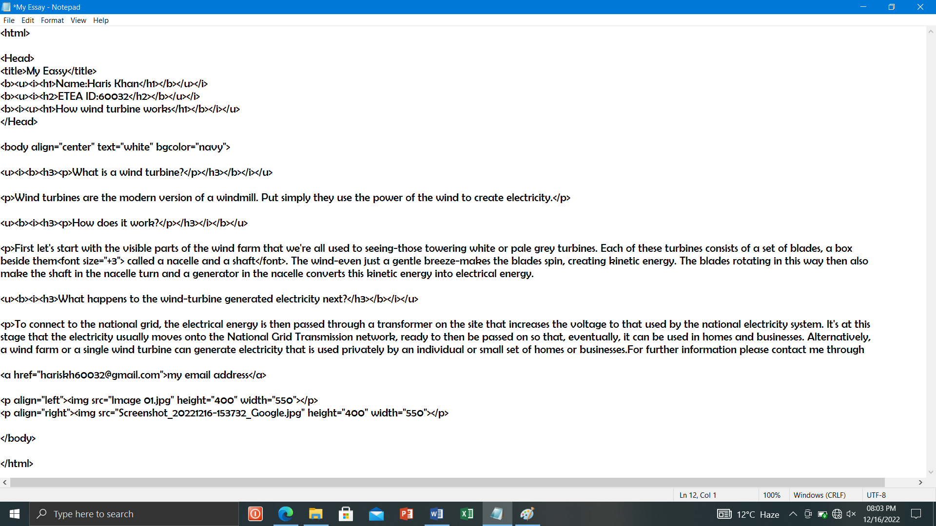

Step#02:
In the second step after completing coding of HTML, I saved it and ran in Microsoft Edge
